Name:

1. (10) Suppose P(x,y) means “x + 2y = xy”, where x and y are integers. Determine the truth value of the statement.

(a). ∀x∃yP(x,y).

(b). ∃x∀yP(x,y).

2. (10) Determine whether (p → q) ∧ (¬p → q) ≡ q using a truth table.

3. (12) In the questions below, suppose A = {a,b,c} and B = {b,{c}}. Mark the statement TRUE or FALSE

a. c ∈ A − B

b. {c} ⊆ B

c. {b,{c}} ∈ 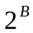

d. {{{c}}} ⊆

4. (10) Suppose f : R → R where f(x) = ⎣x/2⎦ and R denotes the set of real numbers.

(a) Is f 1-1?
(b) Is f onto R?

5. (15) Use the Principle of Mathematical Induction to prove that 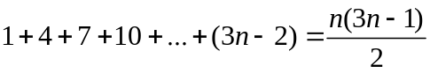 for all n ≥ 1.

6. (10) Suppose you have a class with 10 freshmen, 12 sophomores, and 8 juniors. In how many ways can you get a committee of 7?

7. (10) In the questions below determine whether the binary relation is: (1) reflexive, (2) symmetric, (3) anti-symmetric, (4) transitive.

a. The relation R on {a,b,c} where R = {(a,a),(b,b),(c,c),(a,b),(a,c),(c,b)}.

b. The relation R on R (set of real numbers) where (a, b)R if a − b ∈ Z (set of integers).

8. (10) Determine whether each of the following “theorems” is true or false. Assume that a, b, and m are integers with m > 1.

(a). If a ≡ b (mod m), then 2a ≡ 2b (mod m).

(b). If a ≡ b (mod m), then a ≡ b (mod 2m).

9. (13) Consider the following theorem: If n is an even integer, then n + 1 is odd.

Solutions

1.
a. ∀x∃yP(x,y).
Ans: false

b. ∃x∀yP(x,y).
Ans: false

2.Ans: Both truth tables are identical:

p | q | (p → q) ∧ (¬p → q) | q
T | T | T | T
T | F | F | F
F | T | T | T
F | F | F | F

3
a. c ∈ A − B.
Ans: True
b. {c} ⊆ B.
Ans: False
c. {b,{c}} ∈ P(B).
Ans: True
d. {{{c}}} ⊆ P(B).
Ans: True

4. a. Ans: No. b. Ans: No
5.
Ans: P(1): 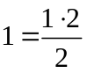 , which is true since 1 = 1. P(k) → P(k + 1): 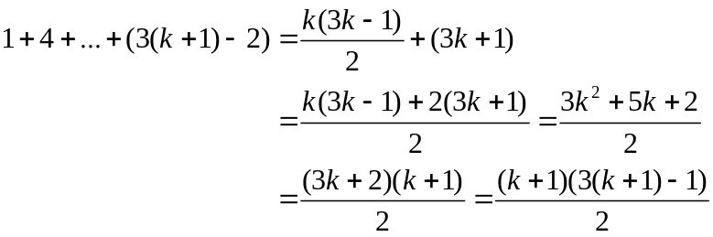

6. Ans: C(30,7)

7. a. The relation R on {a,b,c} where R = {(a,a),(b,b),(c,c),(a,b),(a,c),(c,b)}.
Ans: 1, 3, 4.

b. The relation R on R where (a, b)R if a − b ∈ Z (set of integers).
Ans: 1, 2, 4.

8. a. Ans: true b. Ans: false

9. Ans: Assume n+1 is even, ie, n+1 = 2k for some integer k. Then n=2k-1. Thus, n is odd, contradicting n is even.

